Predicting predator search rates from metabolic rates; a bottom-up modelling approach.

Flavio Affinito1, Miguel Matias2, Samraat Pawar1 and Rebecca L. Kordas1

1. Department of Life Sciences, Imperial College London, Silwood Park Buckhurst Road, SL5 7PY, Ascot UK

2. Museo Nacional de Ciencias Naturales (CSIC), Madrid, 28006, Spain

Formatted for Functional Ecology

Title: currently 6555 words (including references) / 7500 max.

Abstract: currently 289 words / 350 max.

Figures: 1-7

Tables: 0

Equations: 8

Keywords: 9/8 max

References: currently 55

Friendly reviewers (ideas): Tony Dell, Mary O’Connor

Official reviewers (ideas):

**Take home messages:**

1. As species metabolism adapts to temperature, their biological and interactions rates increase with temperature to meet energy demand
2. Predator taxa is benefitting disproportionately from warming of the environment (meta rates & mismatch)
3. Search rates in warm adapted spp seem to increase BUT it depends on spp/interaction type

**Abstract**

**1.** Species adaptation to changes in thermal regimes worldwide is observed in all temperature-dependent traits. Metabolic rates drive species biology and dynamics. We expect that as metabolic rates adapt to new environmental conditions these will result in new mismatches in performance of other biological rates, such as velocity, which will in turn affect predation dynamics via predator search rates.

**2.** Here, we measure three species’ metabolic rates from thermally adapted populations and build on mathematical modelling of biological rates to scale up our findings to predict changes in species velocity and predator search rates. We test for thermal adaptation of three aquatic invertebrates and analyse how the ensuing adaptation patterns are reflected on predator search rates.

**3.** Our empirical work suggests that species adapt to warming by shifting their temperature performance curves vertically with temperature. We find that adaptation patterns are not consistent across species with temperature. Predator metabolic rates increase with warm adaptation whilst prey rates are highest for individuals adapted to intermediate temperatures.

**4.** Mechanistic modelling predictions reveal that the predator species in our system is benefitting disproportionately from the effects of warming via an increase in body velocity relative to that of its prey. This new performance mismatch is also recovered in search rate predictions where warm adapted predators display higher search rates than cold adapted ones regardless of prey type.

**5.** Ecologically sound modelling supported by robust empirical methods allows for the prediction of higher-level species dynamics from simple metabolic rates measurements. Our results provide the first attempt at providing a theoretical framework for predicting species interactions from temperature-dependence of metabolic rates. Key assumptions can be adapted to any system and will allow for a greater understanding of the effects of warming on biological systems.

**Keywords:** adaptation, temperature performance curve, respiration, search rate, velocity, metabolic rate, predator-prey, modelling, metabolic mismatch

**Introduction**

Temperature is one of the most important abiotic factors that influence ecological processes, from individual metabolism (Gillooly *et al.*, 2001) to ecosystem dynamics (Saxe *et al.*, 2001; Yvon-Durocher *et al.*, 2012). The past 50 years have revealed the fastest rise in temperatures ever recorded (Houghton, 1996; Stocker, 2014). These rapid increases in climatic temperature are already affecting a wide range of biological traits and ecological processes that depend on temperature (Coley, Bryant and Chapin III, 1985; Loreau *et al.*, 2001), having a direct impact on species and their interactions (Hughes, 2000; Peñuelas and Filella, 2001). Despite the extensive body of work on how temperature affects species biology (Gillooly *et al.*, 2001; Brown *et al.*, 2004; Kordas, Harley and O’Connor, 2011), we still lack the necessary insight to predict how future changes in global temperatures will affect species interactions. Indeed, we still require a better understating of how long term adaptation to new temperatures of individual species will change the way they interact in novel environments. Recent work suggests that adaptation to differing thermal environments or regimes may cause “metabolic mismatches” between species with nontrivial consequences for predator-prey dynamics (Dell, Pawar and Savage, 2011).

A common approach to model species adaptation to changing environmental temperatures is the thermal performance curve (TPC) of biological traits. Metabolic rates typically display a unimodal relationship with temperature due to the temperature dependence of enzyme kinetics (Angilletta, 2006; DeLong *et al.*, 2017; Kontopoulos *et al.*, 2018; Fig 1A). Local adaptation to thermal regimes results in differing respiration rates within species as demand for ATP in the body increases affecting species biology from growth rates to individual fitness (Clarke, 2003, 2006; Brown *et al.*, 2004). Various scenarios of adaptation of TPCs to new thermal conditions are possible (Kingsolver, 2009; Fig 1B,C), which scale up to their population dynamics (Rall *et al.*, 2010; Vucic-Pestic *et al.*, 2011; Dell, Pawar and Savage, 2014; Gilbert *et al.*, 2014; Pawar, Dell and Savage, 2015). Of these adaptation scenarios, two key ones are displacement in temperature at peak performance (determined by *Tpk*, Fig 1C) and changes in the curve’s elevation (determined by the performance parameter *b0*, Fig 1B) (Angilletta, 2009). Both these have consequences for species interactions by producing mismatches in performance between predators and their prey (Dell, Pawar and Savage, 2014). As species metabolism adapts to new environments, new mismatches will arise and lead to new interactions (Fig 1D, E). These in turn will increase consumption rates, modify community dynamics and could lead to changes in ecosystem assemblage and increased extinction risk (Rall *et al.*, 2010; Albouy *et al.*, 2014).

In this study, we approach the question of thermal adaptation of species interactions by considering how adaptation in respiration rates scales up to predator search rates. Temperature dependence of search rates has been suggested (Rall *et al.*, 2010, 2012; Vucic-Pestic *et al.*, 2011) but proper mechanistic understanding of the relationship is lacking.  Search rates are determined both by the biological traits of the resource and its consumer (Dell, Pawar and Savage, 2014; Gilbert *et al.*, 2014) and the environmental space they interact in (Pawar, Dell and Savage, 2012). Specifically, biotic effects on search rates are determined by the relative body velocities of the predator and its prey (McGill and Mittelbach, 2006; Pawar, Dell and Savage, 2012; Dell, Pawar and Savage, 2014). Research on animal locomotion suggests specific relationships between the energetic cost of transport and metabolic rate based on locomotion type (Tucker, 1970; Videler and Nolet, 1990; Videler, 1993; Alexander, 2003; Hein, Hou and Gillooly, 2012; Gilbert *et al.*, 2014). In part, the energy produced from respiration will be used up for muscle contraction and locomotion (Alexander, 2003). Thus, local adaptation of respiration TPCs will induce changes in velocity TPCs in turn affecting predator-prey ability to forage or escape. Hence, we consider how local adaptation of metabolic rates drives adaptation of species velocity and how the arising mismatches result in altered predator search rates.

Here, we measure individual-level metabolic rates (specifically oxygen consumption) from field data and build on established mechanistic models to predict changes in search rates with temperature. Bridging the gap between metabolism, velocity and search rates via robust mathematical modelling allows for predictions of seldom measured search rates using commonly acquired respiration rates (Gillooly *et al.*, 2001; Brown *et al.*, 2004; Dell, Pawar and Savage, 2011; Huey and Kingsolver, 2011). We use a space for time substitution for adaptation by sampling three taxa of aquatic invertebrates from a large mesocosm experiment set up in the Iberian Peninsula with sites located in regions varying in temperature. All three species of interest are widespread insects in Europe and fill different ecological niches: mobile swimming predator, intermediate consumer and bottom-feeder. Thus, we ask how respiration rates TPCs have adapted to their individual thermal regimes, how this metabolic adaptation affects mismatches in velocity TPCs and how this mismatch affects predator search rates.



Figure 1. **Thermal adaptation of temperature-dependent rates may lead to mismatches in performance between interacting species.** (A) Metabolic rates can be modelled as a unimodal function of temperature determined by biochemical processes (enzyme activation (*Ea*) and deactivation (*Ed*) energies) and biological parameters (*Tpk* and *b0*) from equation 1. Adaptation to increases in temperature give rise to different patterns. (B) A vertical shift in performance (*b0*) may arise when a species has adapted to higher temperatures or (C) a horizontal displacement in the whole TPC may arise when a species adapts to higher temperatures. (D) At cooler temperatures, predator (yellow) and prey (green) may have similar TPCs. (E) If predator and prey adapt to higher temperatures in different ways (eg, predator adapts via scenario (B) and prey adapts via scenario (C)), then their TPCs may become ‘mismatched’. Adapted from Angilletta, 2009; Kingsolver, 2009; Anthony I Dell, Pawar and Savage, 2014.

**Empirical Methods**

STUDY SITES

To determine how insect species have adapted to different temperature conditions, we used a space-for-time substitution. We measured oxygen consumption rates of insects from six sites around the Iberian Peninsula, that varied in altitude and latitude (Fig 2). At each site, 32 artificial mesocosm ponds (each 320L) were seeded with an assemblage of freshwater species collected from a nearby pond?? in (month??) 2015. The communities in the mesocosms were then left to assemble naturally over the following two years. Most invertebrate species found in the ponds are efficient dispersers upon reaching adult stage and were found throughout ponds at each site (Matias, unpublished data). The sampling period for this study corresponded to the local spring season at each site (April to May, 2017). Mesocosm temperatures were recorded with submerged loggers every hour since the set up of each experimental site (2 to 3 years). The sites experienced different local climates and mean temperatures: Peñalara (7.35±0.05°C), Jaca (11.05±0.04°C), Porto (12.7±0.03°C), Toledo (13.47±0.03°C), Évora (14.92±0.03°C) and Murcia (16.23±0.03°C).

STUDY ORGANISMS

Experiments were carried out on three insect species native to ponds of the Iberian Peninsula. Individuals were collected with 500μm mesh nets from their home ponds and were identified to species level following experiments and preservation. We targeted species based on abundance at each site (>100 individuals) and trophic level (predator vs. prey). Not all species were found in sufficient numbers at all six sites (Table S1).

Predator foraging strategy was determined for each prey based on differences in morphology and locomotive behaviour. In their larval stage, both *C. dipterum* and *S. striolatum* are free-swimming pelagic species (Merritt and Cummins, 1996; Bauernfeind and Soldan, 2012). In contrast, *Chironomus* spp. are benthic and found mostly living in the sediment (Cranston, Pinder and Armitage, 1995). We define foraging strategies based on the relative velocities of prey and predator (Pawar, Dell and Savage, 2012). When prey velocity is likely to be negligible relative to that of the predator, we classified it as a “sessile prey” strategy. In contrast, when prey velocity is non-negligible and likely to affect model predictions, we defined the foraging strategy as “active capture”. These distinct foraging strategies are expected to produce different interaction strengths based on the environmental space they occur in and are thus considered in conjunction for search rate modelling.

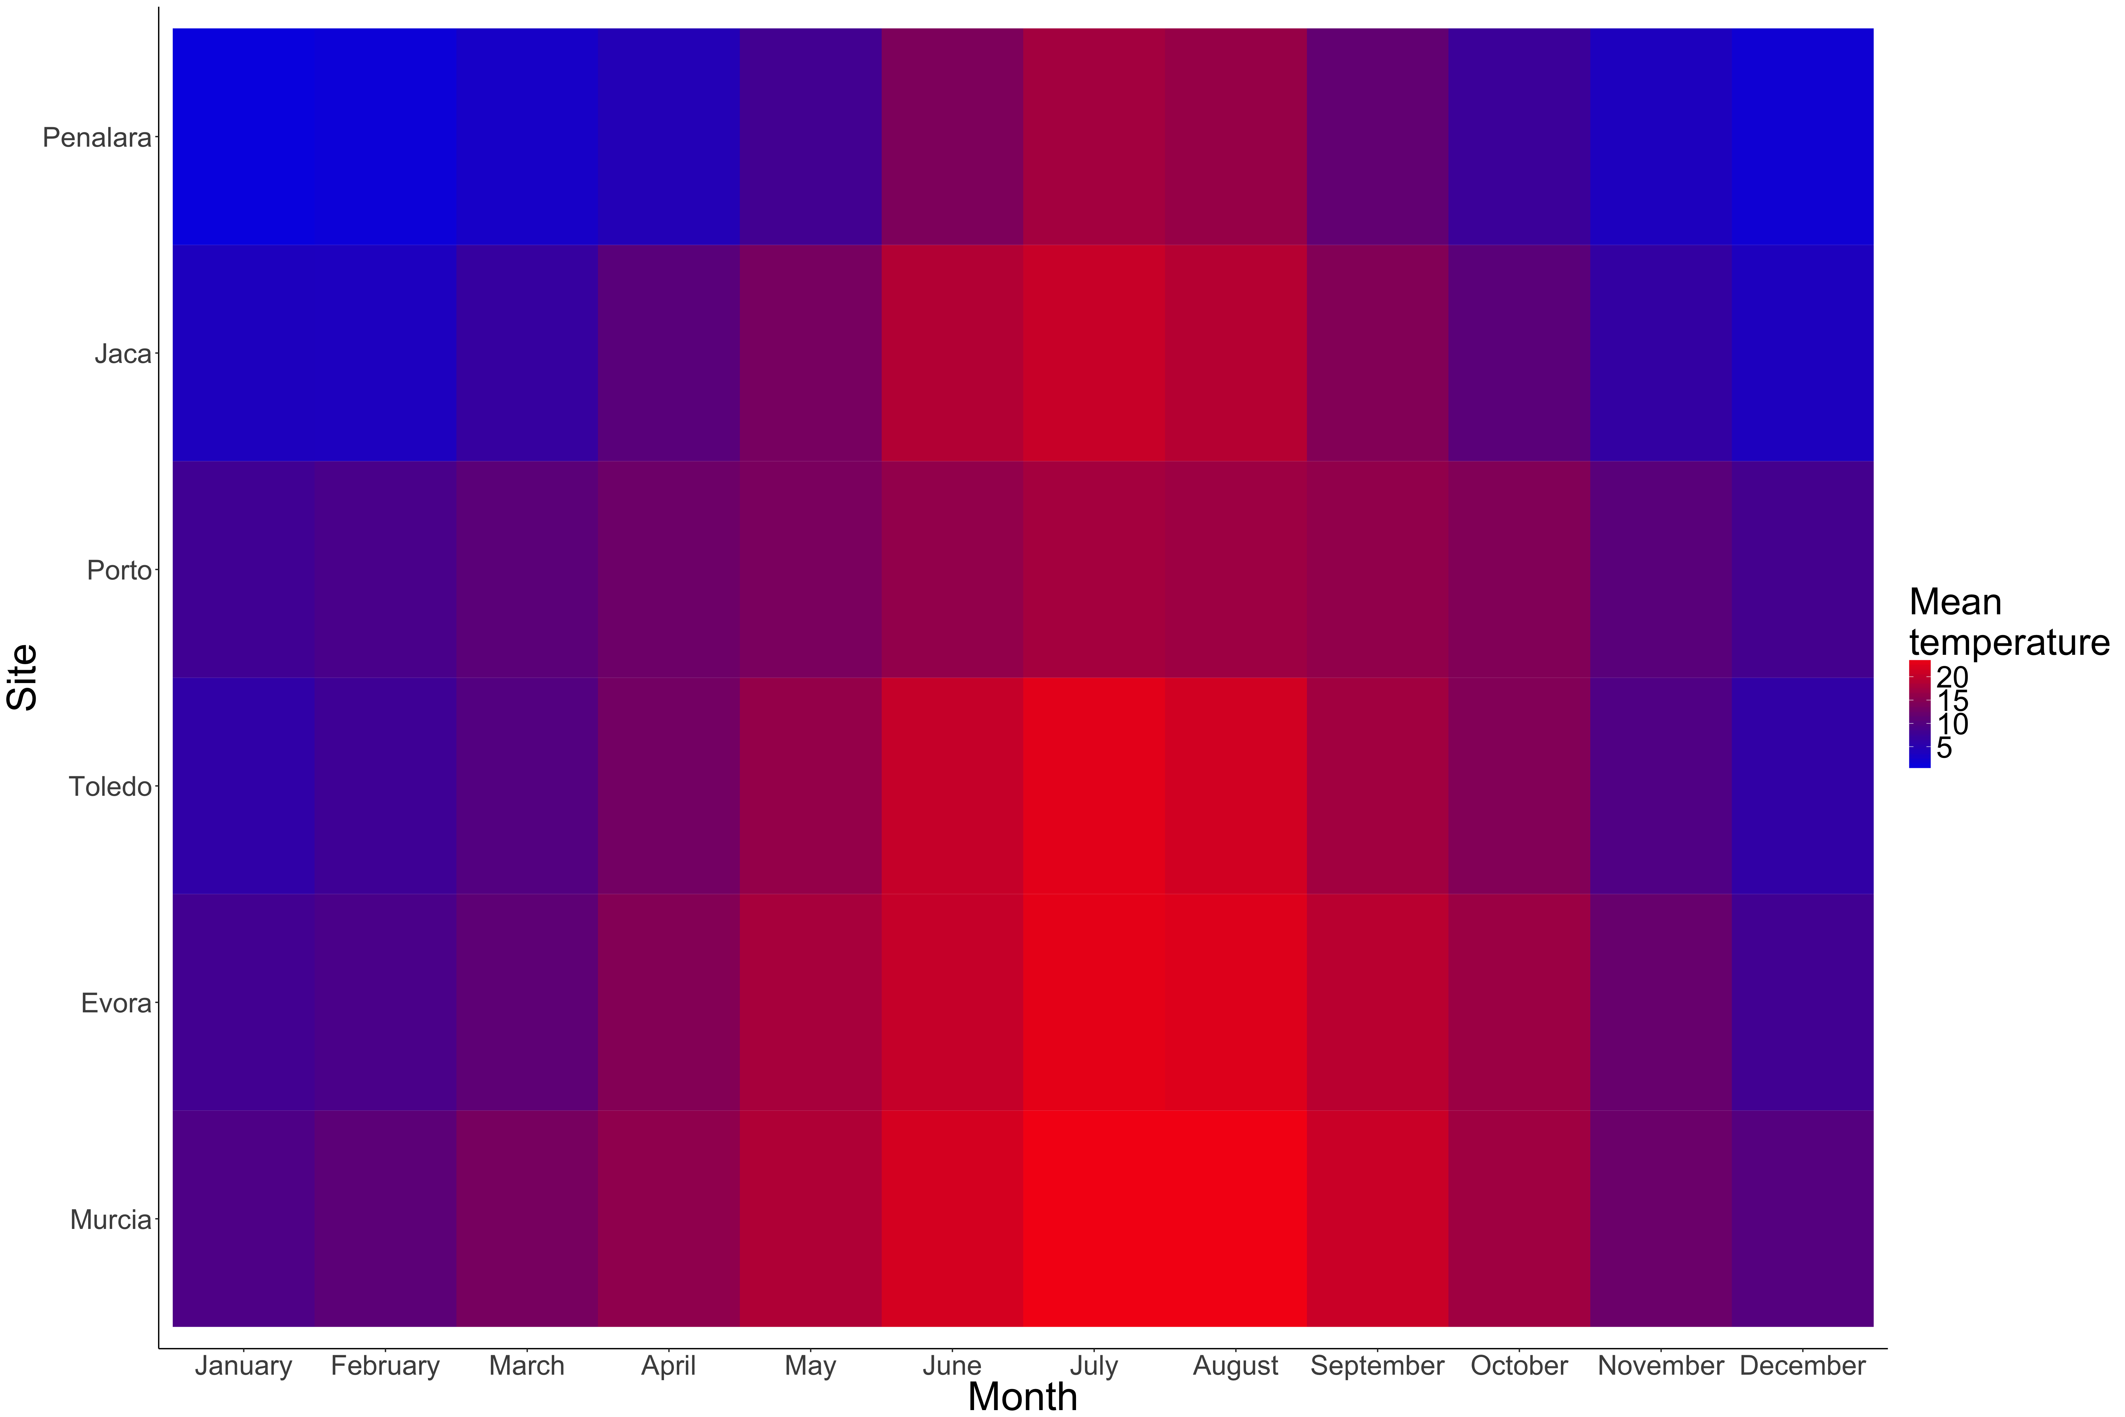

Figure 2. Mean monthly temperatures recorded at each site. We used a space for time substitution to measure thermal adaptation as all sites experienced differences in temperatures due to their geographical position.

METABOLISM EXPERIMENTS

Metabolic rates increase as demand for ATP in the body increases (Clarke, 1993), requiring that individuals consume more oxygen per unit time (Clarke, 2003, 2006), thus we measured oxygen consumption rate as a proxy for metabolic rate. We measured metabolic rates following a protocol similar to that of Brodersen et al 2008. Since it is necessary to capture both the rise and fall components of TPCs to avoid introducing bias in the estimation of their activation energies (Pawar *et al.*, 2016), we measured respiration rates of individuals at temperatures spanning 10-45°C at 5°C intervals. For each population, we measured the oxygen consumption rate of 50-100 individuals for each TPC (7-14 individuals per acute temperature).

Individual insects were collected & stored for 24 hours in containers filled with mesocosm water that had been filtered using 20μmmesh nets and held at ambient temperature. This allowed for gut clearing of all taxa, since digestion status can affect respiration rates. Individuals were acclimated to acute experimental temperatures for 15 minutes prior to respiration measurements to avoid a shock response; insects were placed in a plastic container filled with 100ml of filtered pond water at ambient temperature, which was then placed in a water bath set to the acute temperature. This allowed the water inside the container to reach the acute temperature within ~15 minutes.

For each respiration trial, eight glass vials were filled with filtered air-saturated water from the mesocosms, which was kept at the experimental temperature. A magnetic stir bar maintained mixing of the water column in each glass vial, and a small mesh screen was placed in between the stir bar and the organism to avoid stressing the organism. Individuals were placed into seven of the glass vials, while the eighth vial contained filtered water only and thus served as a control to account for sensor drift and the oxygen changes due to microorganisms in the mesocosm water. All vials were then sealed and fully immersed in a water bath set to the experimental temperature. Individuals were only used once.

Oxygen concentration was measured during three periods of ~30 seconds each (logging every second) using an oxygen microelectrode (MicroResp, Unisense, Denmark) fitted through a capillary in the lid of each vial. Oxygen concentrations were not allowed to drop below 70% of the starting value, to avoid stressing the insects. The oxygen consumption rate of each individual was calculated as the slope through all of the data points, and was corrected for differences in vial volume and the oxygen concentration in the control vial from each trial. The body size of each individual was measured using a dissecting microscope and converted to dry mass using length-weight relationships measured for taxa from our sites (Supplementary methods)

**Modelling**

Temperature dependence of respiration was modelled using the Sharpe-Schoolfield model (Schoolfield, Sharpe and Magnuson, 1981). This model was chosen for its ability to capture both the rise and fall of temperature-dependent rates based on biologically relevant parameters. Not enough measurements were available to estimate low temperature enzyme inactivation thus the model used here was reduced to:

|  |  |  |
| --- | --- | --- |
|  | $$B= \frac{b_{0}m^{β}e^{\frac{-E_{a}}{k}\left(\frac{1}{T}-\frac{1}{T_{ref}}\right)}}{1+ e^{\frac{E_{d}}{k}\left(\frac{1}{T_{pk}}-\frac{1}{T}\right)}}$$ | (1) |

Where *B* is oxygen consumption rate, *b0* is the normalisation constant at a reference temperature (*Tref*), *m* is mass, *β* is its scaling exponent, *Ea* is the enzyme’s activation energy, *Ed* is its deactivation energy, *k* is Boltzmann’s constant, *T* is temperature and *Tpk* is the temperature at which the *B* is maximised. We expected baseline performance to be adapted to the temperatures experienced at a species’ local habitat. Thus, each site’s mean temperature was used as reference temperature (*Tref*) to estimate a biologically relevant value for *b0*. We fitted the model with a mass term added to account for species-specific variation in mass scaling for both prey species and set *β=0.75* (Brown *et al.*, 2004)for the predator taxa after a model choice procedure was carried out (Supplementary material). All parameters were estimated via non-linear least squares fitting of the model to the data collected for each species at each site using the ”minpack.lm” package (Elzhov *et al.*, 2016) for the statistical software R (R Core Team, 2015). Starting parameters for the fitting were sampled 10,000 times from a normal distribution centred on values estimated from a linearised Arrhenius function to determine the parameter values that yielded the best fit to the data. Best fit was determined based on highest R2 and lowest AIC and BIC when R2 values were equal.

Sharpe-Schoolfield models (equation 1) were fit to the respiration data for each population. The best-fit model out of 10,000 runs in each case was kept to estimate the values of *Ea, Ed, B0, β* and *Tpk* (Table S4). Respiration curves were then plotted for each taxa at each site to compare adaptation patterns. Estimated parameter values from each TPC were then compared between populations. Parameter values were considered statistically different from each other when associated 95% confidence intervals did not overlap.

Scaling up from respiration measurements, we can model velocity rates’ temperature dependence from respiration TPCs. The energetics of animal movement, and specifically swimming, have been extensively studied for various species (Videler and Nolet, 1990; Videler, 1993; Alexander, 2003). Assuming that velocity scales linearly with metabolic rate (Tucker, 1970; Alexander, 2003), there exists a relationship between cost of transport (*C*), the amount of energy (in J) needed to transport 1N over 1min submerged swimmers, and metabolic rate (*B*). Rearranging Videler’s equation for velocity yields:

|  |  |  |
| --- | --- | --- |
|  | $$v= \frac{B}{Cmg}$$ | (2) |

Where *B* is in J.s-1, *m* is mass in kg, *g* is gravitational acceleration in m.s-2, *v* is velocity in m.s-1, *C* is expressed in J.Nm-1and was calculated from: *C* = 1.1*m*-0.038 (Videler, 1993).

We assumed that the energy provided for muscle contraction and velocity comes from the combustion of nutrients via oxygen consumption (Merrill and Watt, 1973; Elliott and Davison, 1975; Food and Agriculture Organization, 2015). Metabolism TPCs for each predator-prey pair, at each site, were thus converted into a measure of velocity using equation 2*:*

|  |  |  |
| --- | --- | --- |
|  | $$v=\frac{Bγ}{1.1m^{0.962}g}$$ | (3) |

Where *γ* is the conversion coefficient of oxygen combustion into energetic output. The temperature dependence of *v* is captured in the *B* term (from equation 1). There are known limitations to this model: measured metabolic rates are used as a function of velocity without taking into account increases in metabolism during activity and the efficiency of energy conversion by muscles is ignored. Nevertheless, we expect that this model will provide us with a mechanistic prediction of species velocity which can in turn be used to predict predator search rates in various conditions and for any given species where mass and metabolic rates are known.

To estimate the strength of predator-prey interactions, we focused on search rate, the rate at which a consumer moves through an area or volume while searching for prey. In field conditions, search rate is a key limiting rate underlying consumer-resource dynamics because it determines the rate of encounter when resources are relatively rare (McGill and Mittelbach, 2006; Pawar, Dell and Savage, 2012). Search rates are determined both by environmental space and biological traits as:

|  |  |  |
| --- | --- | --- |
|  | $$a= v_{r}D$$ | (4) |

Where *vr* is the relative velocity of a predator and its prey and *D* is the dimensionality component of search rates. Velocity is a biological rate that can be modelled as a function of temperature (Dell, Pawar and Savage, 2014). The temperature dependence of relative velocity for two species moving randomly can be included into equation 4 from equation 3 for both the consumer and resource species (Supplementary material) as:

|  |  |  |
| --- | --- | --- |
|  | $$a= \left(b_{0,c}{m_{c}}^{β_{c}}e^{\frac{{-E}_{c}}{k}\left(\frac{1}{T}-\frac{1}{T_{ref}}\right)}+\sqrt{1+{\left(\frac{b_{0,r}}{b_{0,c}}\right)}^{2}{\left(\frac{{m_{r}}^{β_{r}}}{{m_{c}}^{β_{c}}}\right)}^{2}e^{\frac{2}{k}\left(\frac{1}{T}-\frac{1}{T_{ref}}\right)\left(E_{c}-E_{r}\right)}}\right)D$$ | (5) |

Where *b0* is the normalisation constant for velocity at a reference temperature (*Tref*), set here at the mean temperature for each site, *m* is mass, *β* is the mass scaling exponent, *E* is activation energy, *T* is temperature in K?, *k* is Boltzmann’s constant and *c* or *r* subscripts correspond to consumer and resource parameters respectively. This model predicts the search rate of a predator foraging on an active moving prey in different environments, for benthic species, such as *Chironomus* spp., it can be adapted to a scenario for sessile prey by setting the prey’s velocity to 0:

|  |  |  |
| --- | --- | --- |
|  | $$a= b_{0,c}{m_{c}}^{β_{c}}e^{\frac{{-E}_{c}}{k}\left(\frac{1}{T}-\frac{1}{T_{ref}}\right)}D$$ | (6) |

We can expand the dimensionality term *D* for interactions taking place in 2D or 3D (Pawar, Dell and Savage, 2012). We modelled search rates separately in 2D or 3D interactions as follows:

|  |  |  |
| --- | --- | --- |
|  | $$2D :a=v_{r}2d_{0}{(m_{c}m_{r})}^{p_{d}}$$ | (7) |

|  |  |  |
| --- | --- | --- |
|  |  | (8) |

Where *d0* is the minimum reaction distance, *mc* and *mr* are average consumer and resource body mass respectively, and *pd* is the scaling exponent of mass with dimensionality. The values of *pd* in 2D and 3D were empirically derived from meta-analysis and are equal to 0.68 and 1.05 respectively (Pawar, Dell and Savage, 2012).

The model’s output was compared between predator-prey pairs adapted to warm and mild environments to observe the effect of local adaptation on search rates. We used a linearised Arrhenius function to estimate the biological parameters determining search rates (*Ea* and *b0*) at each site and for each strategy and plotted the changes in parameter values to look for adaptation of search rates in warmer environments.

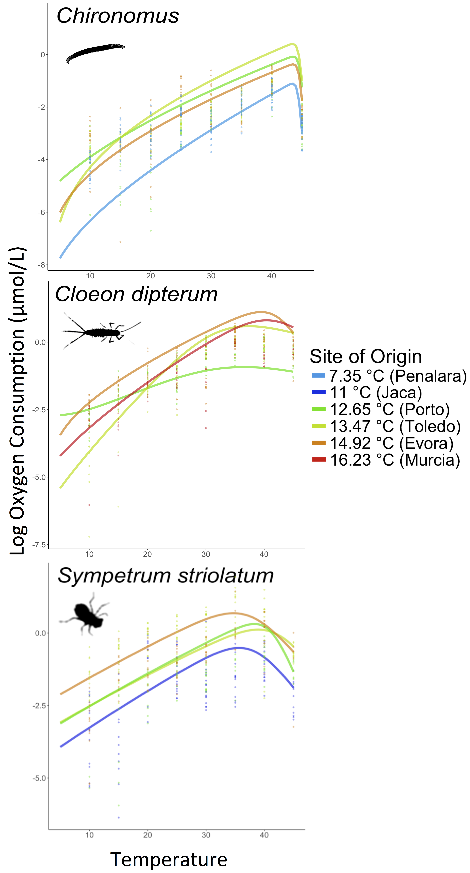

Figure 3. **Metabolic thermal performance varies across sites.**

Respiration temperature performance curves for *Chironomus* *spp*, *C. dipterum* and *S. striolatum* display an adaptation scenario corresponding to conceptual Fig 1B. Note that curves for the coolest and hottest adapted populations are lower than those for intermediate sites for both prey species.

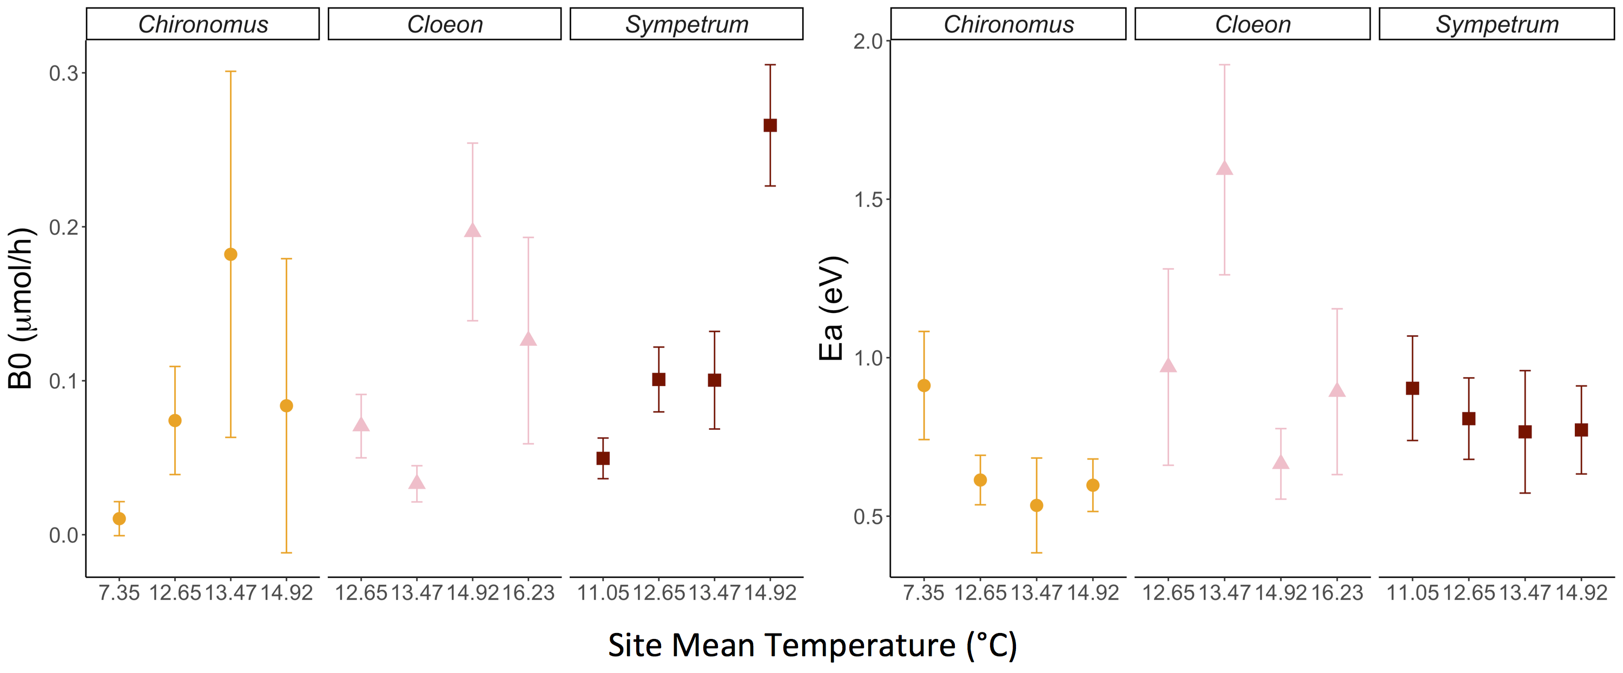

Figure 4. **Parameter estimates for each species, from each site.** Parameter estimates, associated with biological traits, show significant differences in adaptation to local thermal environments within taxa. Note that variation in parameter values is stronger for *b0* than *Ea*.

**Results**

The temperature dependence of respiration rate

A horizontal shift in TPC (Fig 1C) between locally adapted populations were not supported for any taxa (Fig 3). All three taxa adapted to new thermal environments by shifting their TPCs vertically (Fig 1B & 3). We recorded a monotonous increase in *b0* with site temperature for the predatory *S. striolatum* whilst *C. dipterum* and *Chironomus* spp. TPCs displayed higher elevation for the warmest site in comparison to the coolest one but revealed higher *b0* values at intermediate sites than at either extreme (Fig 3 & 4). Significant variation in *Ea* was recorded for both prey taxa in the cooler sites, with colder adapted populations showing steeper activation energies (Fig 4b). Activation energy did not differ between sites for *S. striolatum* (Fig 4b).

Velocity curve elevation increased for *C. dipterum* and *S. striolatum*: 0.55±0.02m.s-1 versus 0.59±0.06m.s-1 and 0.58±0.02m.s-1 versus 0.78±0.04m.s-1 in Porto and Évora respectively. *Chironomus* spp. velocity *b0* decreased with adaptation to a warmer environment: 0.17±0.04m.s-1 versus 0.15±0.10m.s-1 in Porto and Évora respectively. We found higher elevation of the predator curve relative to the prey at warmer adaptation temperatures for both prey taxa: Δ*b0*=0.41m.s-1 versus Δ*b0*=0.63m.s-1 for *Chironomus* spp. and Δ*b0*=0.03m.s-1 versus Δ*b0*=0.19m.s-1 for *C. dipterum* in Porto and Évora respectively. Although adaptation to warmer environments increases elevation for one prey species and the predator in our system, the relative difference in curve elevation increases as predator *b0* increases faster than that of either prey taxa over the OTR (Fig 5).

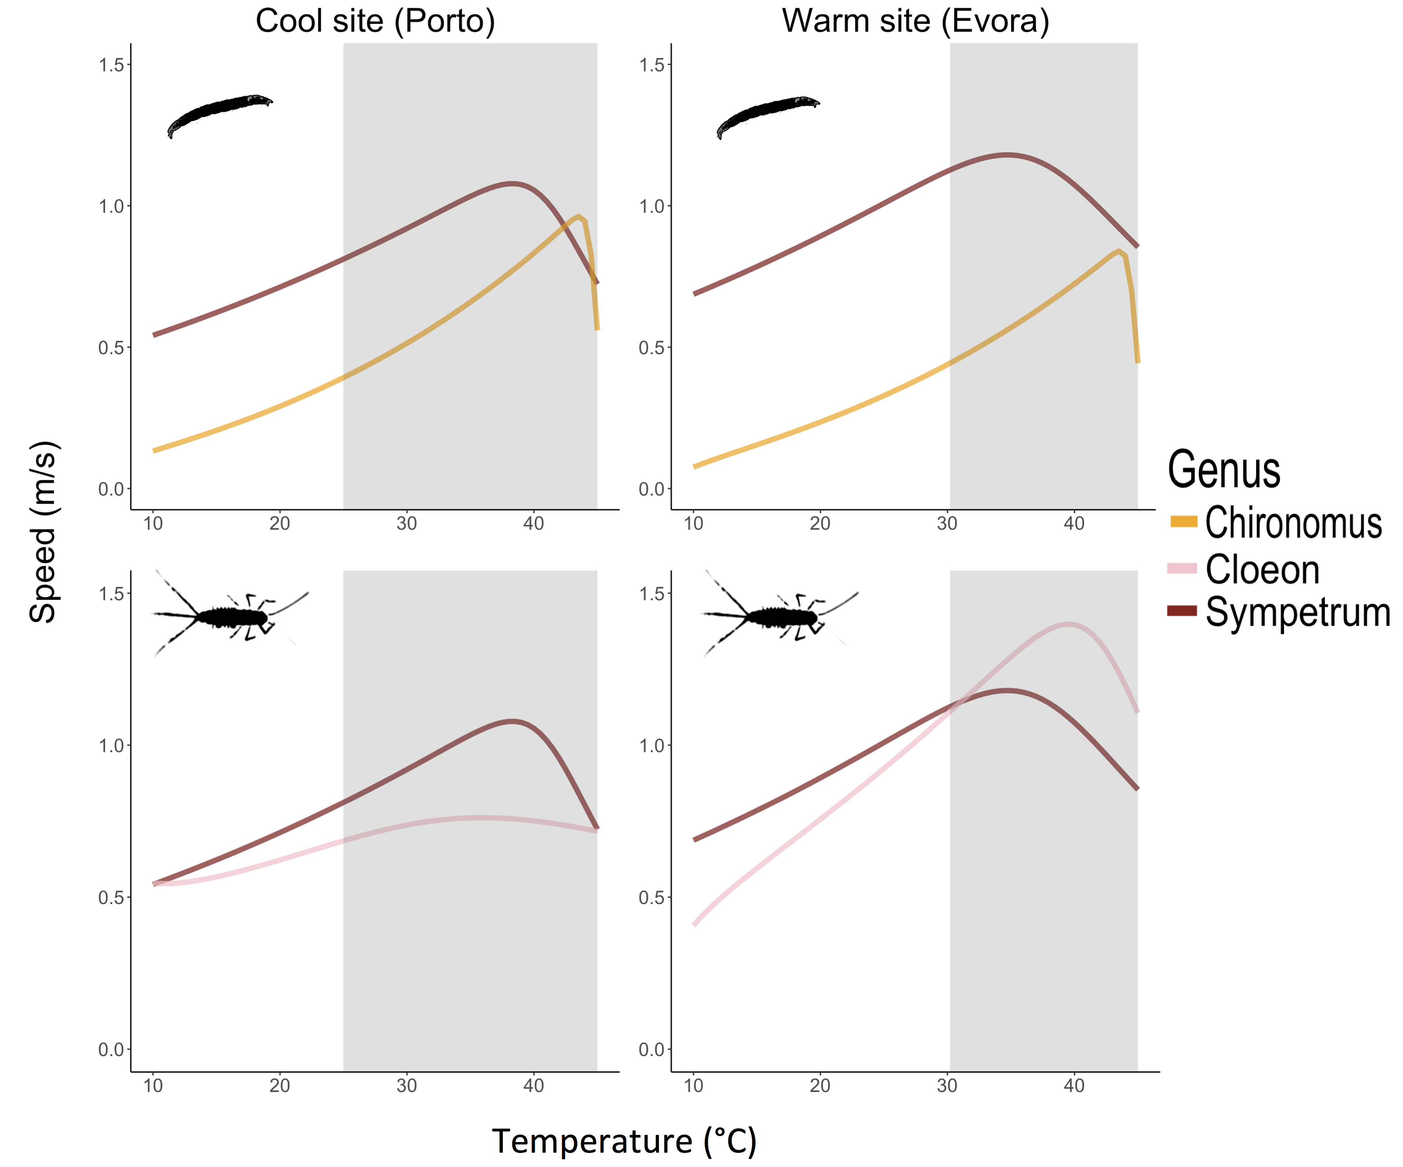

Figure 5. **Mismatches in velocity with adaptation temperature.** Predator-prey velocity curves for mild Toledo versus hot Évora for each predator-prey pair show mismatches in elevation and peak performance temperature. Changes in relative performance in warmer environments place both prey taxa under higher pressure from predation as *S. striolatum* displays relatively higher velocity over much of the operational temperature range (non grey area).

EFFECT OF TEMPERATURE ON SEARCH AND ENCOUNTER RATES

Modelling search rates based on mechanistic parameters revealed that consistent patterns emerge in all scenarios. For both species pairs and all strategies at both sites, search rate increased exponentially with acute(?) temperature (Fig 6). The active 2D strategy displayed the highest search rates over the OTR in all cases. These were followed by 2D sessile prey model predictions for *Chironomus* spp. and 3D active prey predictions for *C. dipterum*. Search rates for the 3D sessile prey model were consistently smaller for both species pairs at each site. The remaining 3D strategy fell in between for *Chironomus* spp. whilst the last sessile strategy took that position for *C. dipterum*.

Both activation energy and elevation of all search rate models increased for both species pairs after warm adaptation (Fig 7). Increases in *b0* revealed more variability than those in *Ea*. Parameters of search rates of *S. striolatum* foraging on *C. dipterum* revealed a stronger increase with site temperature than those for *Chironomus* spp.

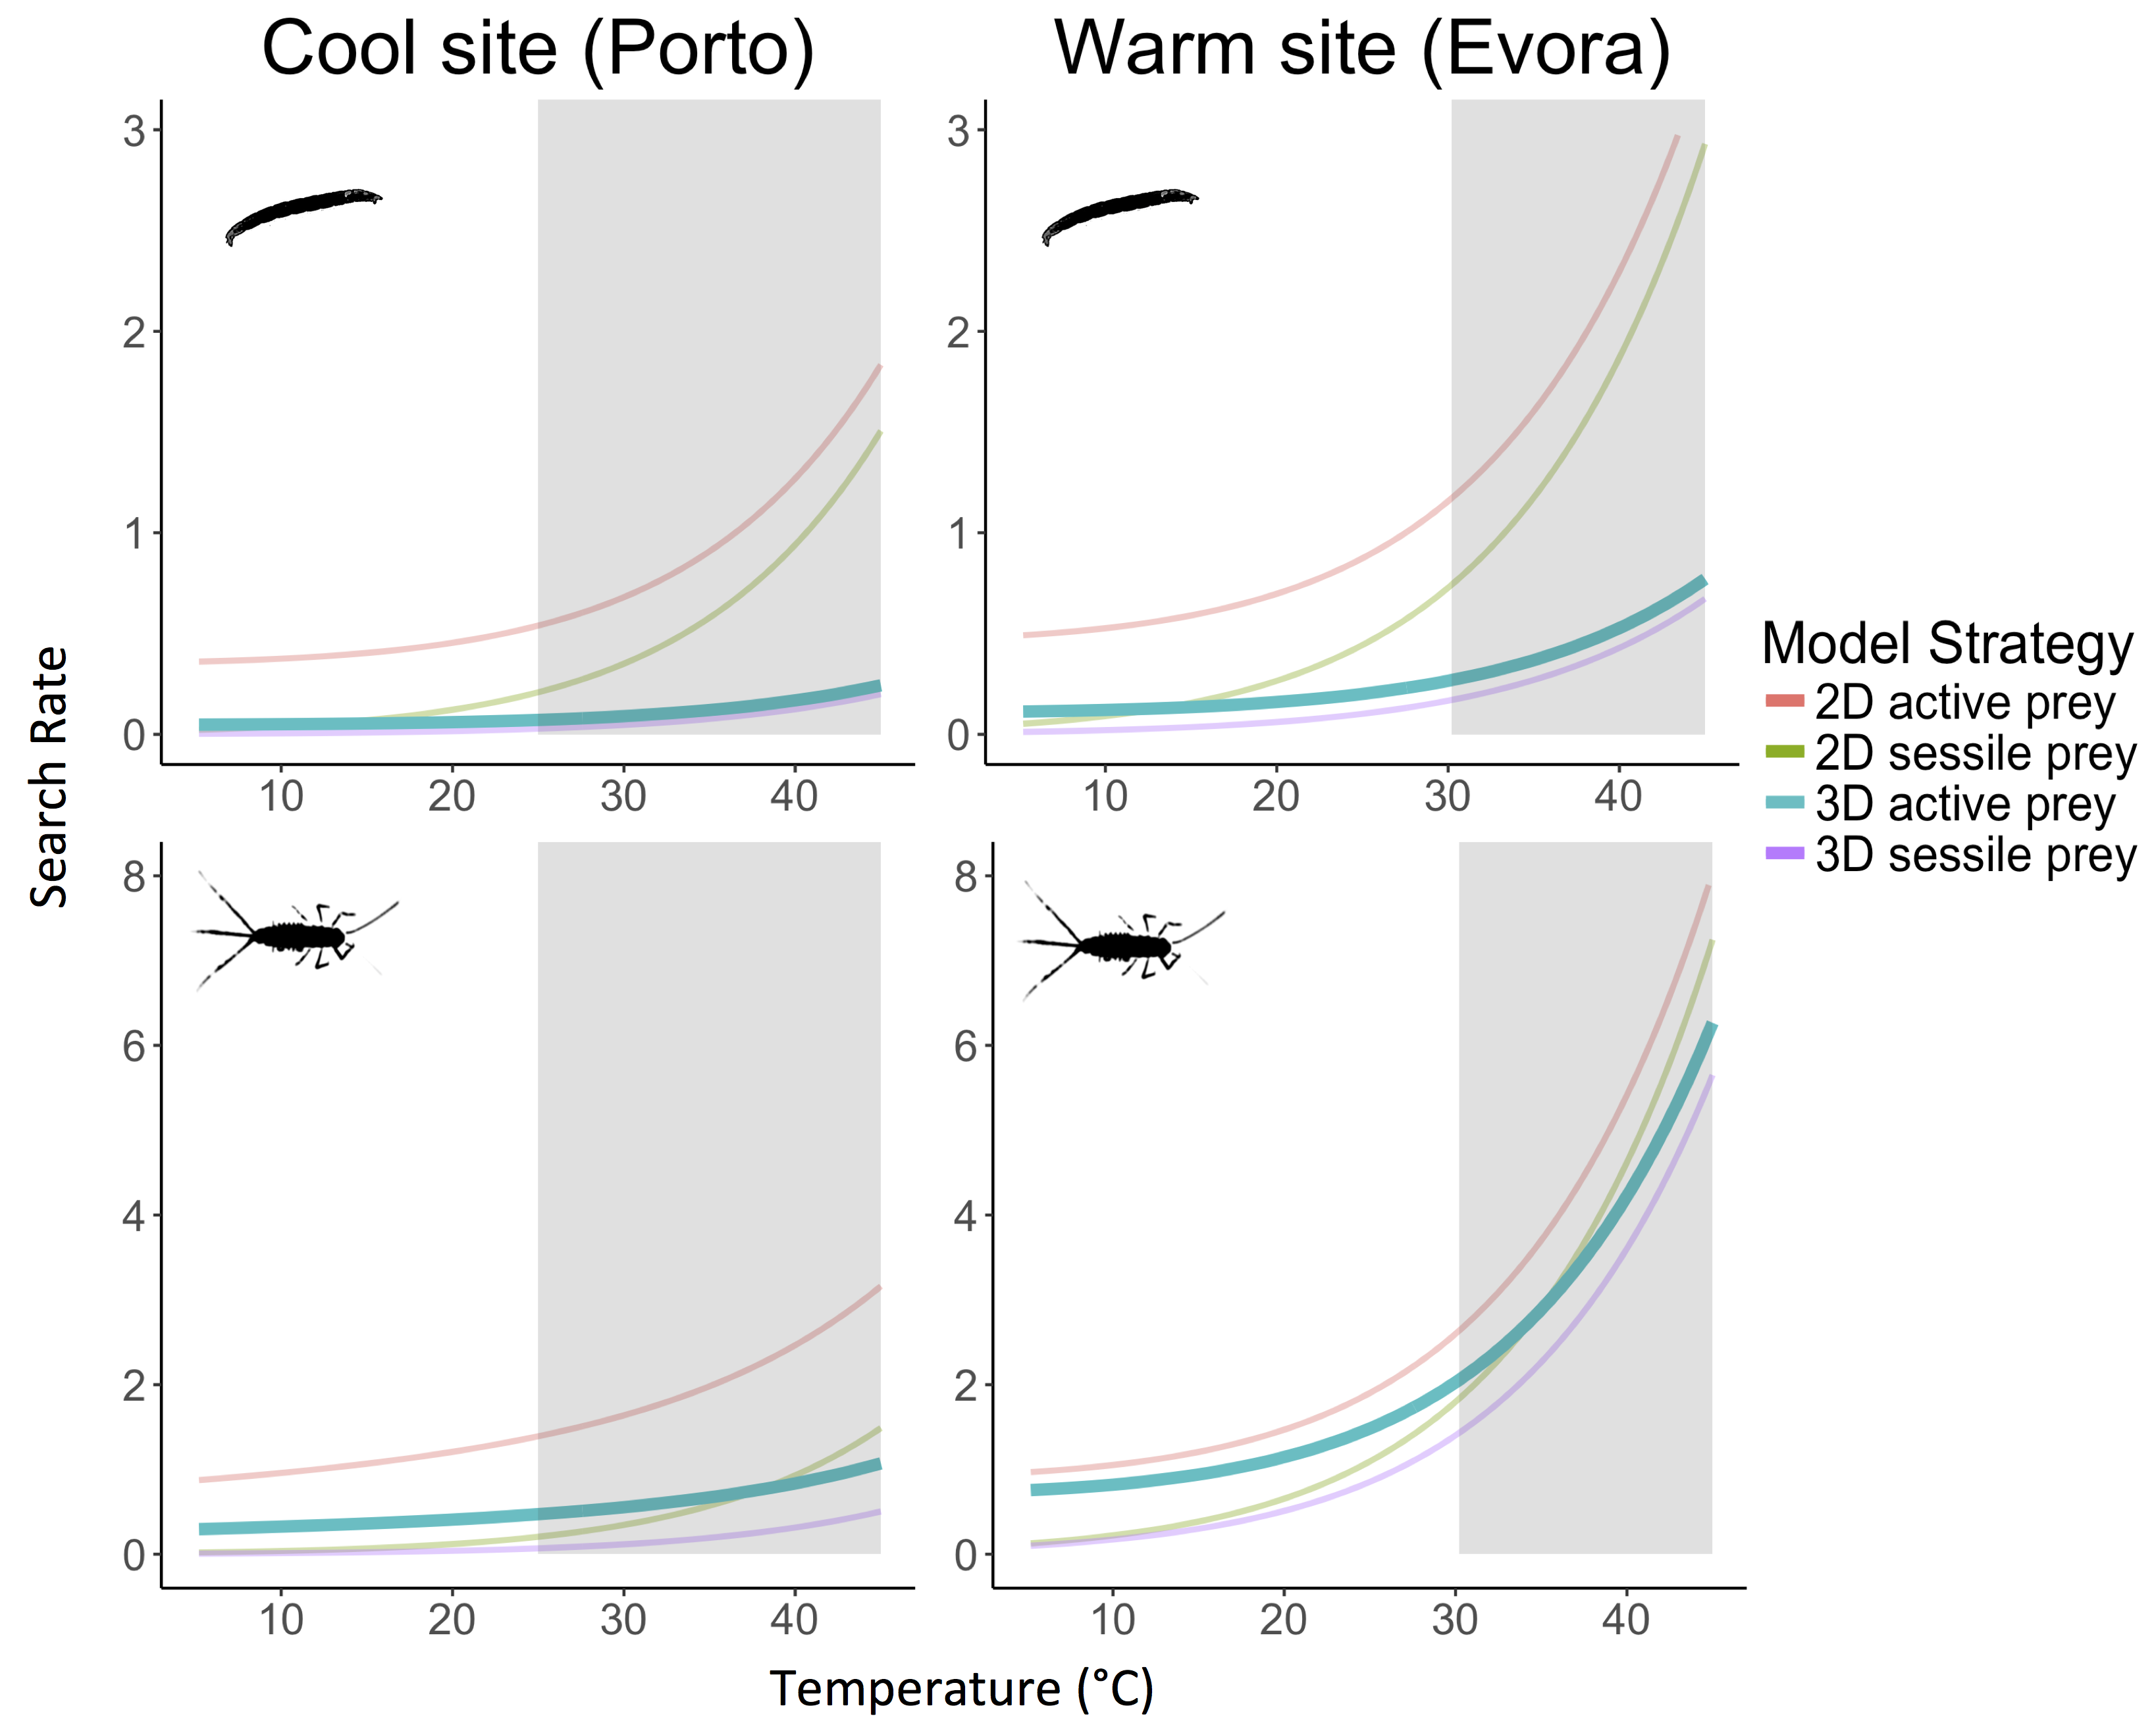

Figure 6. **Site-specific exponential increase in search rates with temperature.** Search rate models' predictions for *Chironomus* spp. and *C. dipterum* in mild Porto or warm Évora show similar predictions in search rates within the OTR (non grey area). Thicker/Bolder(?) curves correspond to the most biologically relevant model for the interacting pair. The model predicts exponential increases in search rate with temperature, but this increase is not equally strong for all strategies, and appears strongest in warm-adapted pairs.

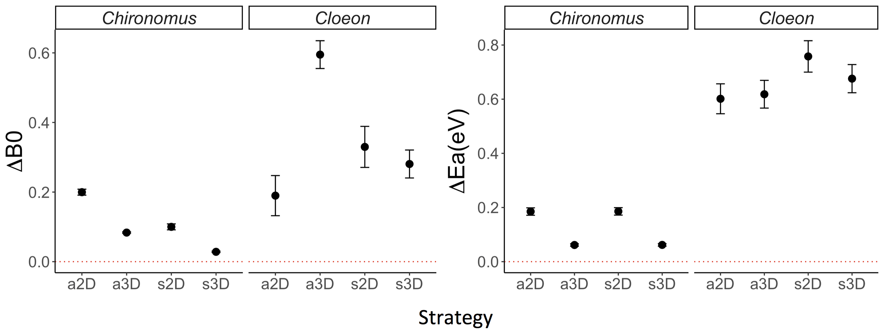

Figure 7. **Differences in search rate activation energy and baseline performance between warm and cold acclimated species.** Search rates for *Chironomus* spp.and *C. cloeon* display an increase in both elevation (Δ*b0*) and activation energy (Δ*Ea*) for all strategies after adaptation to a warm site.

**Discussion**

The current study aimed to identify patterns of metabolic adaptation to new thermal regimes and explore how changes in metabolic rates scale up to velocity and species interactions. Species-specific population temperature performance curves in this study display a vertical shift in the whole curve with increasing temperature (Fig 1B and 3). We did not observe any significant horizontal shift in the TPCs (Fig 1C). Increases in temperature in this system have led to increased energy demand for ATP production pushing these three taxa to modify their respiration TPCs to meet this demand via increased oxygen consumption. Yet, this observed increase is not monotonous or consistent between species. Whilst the predatory dragonfly TPCs increase in elevation as they adapt to hotter sites such a relationship is not observed in their prey (Fig 3 and 4). Both prey species display lower elevation at temperature extremes than intermediate temperatures, suggesting a potential optimum adaptation towards the mid-range temperatures of the OTR as the cost of increased energy demand becomes too high past a threshold temperature. Furthermore, it is worth noting that the value for *Tpk* is higher than the operational range of temperature (Fig 3). Displaying *Tpk* values at unrealistically high temperatures of 35 °C or more provides a margin of safety to these taxa should climate change bring ambient temperatures higher than they currently are.

Converting metabolic rate measurements into velocity, a key driver of species interactions (Dell, Pawar and Savage, 2014), enabled us to directly consider the mismatch in functional trait performance between prey and predator for different species pairs (Fig 1D&E and 5). Our study suggests that species velocity will increase for populations adapted to warmer conditions, which will lead to asymmetrical(?) changes in performance and thus interaction types and strengths (Angilletta, 2009; Kordas, Harley and O’Connor, 2011; Gibert and DeLong, 2014; Pawar, Dell and Savage, 2015). In this case, the predatory dragonflies may be better able to feed on both these prey speciesthroughout their OTR as they are able to move faster, increasing potential attack and capture rates. Despite an increase in prey velocity TPCs elevation, the increase in that of their predator causes a stronger mismatch in hotter environments. The monotonous increase in *S. striolatum* respiration *b0* measured here suggests this predator may be better suited at adapting to a warmer environment thus benefiting disproportionately from such environmental changes. This increase in velocity with temperature will result in increased energy demand, which may be met by better foraging efficiency provided by the new mismatch expected here. Decreased oxygen concentration in warm water (Gilbert *et al.*, 2005) may be limiting both *C. dipterum*’s and *Chironomus* spp.’s ability to adapt to hotter environments. Indeed, mayfly and chironomid species are very sensitive to low *O2* environments (Panis, Goddeeris and Verheyen, 1996; Bauernfeind and Soldan, 2012). These results suggest that although species may adapt to an environment in similar ways, the magnitude of their scope for adaptation may cause new mismatches that will be detrimental to a species despite the apparent benefit of a warmer environment.

Predator-prey interactions are key to community-level dynamics in aquatic environments (Pawar, Dell and Savage, 2015). Here we show that it is possible to predict the behaviour of search rates from a mechanistic model relying on metabolic rates data. We find support for an exponential increase in search rates with temperature (Brown *et al.*, 2004; Vucic-Pestic *et al.*, 2011; Rall *et al.*, 2012). This relationship is maintained across foraging strategies but the magnitude of the increase varies, emphasizing the importance of environmental dimensionality in species interactions (Pawar, Dell and Savage, 2012). The strength of the relationship between search rates and temperature depends both on dimensionality and on the species interacting in that space (Fig 6). Here, we find that dimensionality plays a ~~stronger~~ role in search rates for *Chironomus* spp. whilst foraging strategy drives increased search rates in *C. dipterum*. Indeed, 2D environments display the sharpest increase for the former whilst it is active strategies for the latter. Thus, although biochemical processes result in similar patterns of search rate increase with warm adaptation, it is important to consider specific prey items and the environment they interact in when modelling search rates. Nonetheless, the overall increase in search rate elevation in warm adapted species (Fig 7) suggests that as the difference in performance of velocity increases, so do search rates. These results support the idea that the predator in this study will benefit disproportionately from the warming of its environment.

The set of assumptions of this model may limit its application to all types of predator-prey pairs. First, random movement has been shown to approximate animal dispersion in most cases but may not suffice in all (Pawar, Dell and Savage, 2015). Second, the effect of dimensionality is largely dependent on the environment and the predator’s detection mechanism, as *d0* (minimum detection distance) will depend both on the environmental medium (eg, air vs. water) and trait used (Pawar, Dell and Savage, 2012). Third, the model uses an established relationship for general forms of movement in water and cost of transport (Tucker, 1970; Videler and Nolet, 1990; Videler, 1993). Alternatives can be used based on specific locomotion techniques and the physics involved therein but this was not available for our taxa (Alexander, 2003). We suggest that this drawback is only minor, for it is much easier to find information on higher taxa’s locomotion and work is on-going on the physics of animal movement with regard to metabolism (Hein, Hou and Gillooly, 2012; Gibert *et al.*, 2016). However, these shortcomings all point towards the fact that more empirical work on life history, habitat choice and animal movement is needed for a better integration of computational methods into biological studies. Finally, for ease of study and because no such information was available, we ignored energetic budgets and assumed that all the energy produced by metabolism was used for locomotion. This assumption will be broken in all cases as the energy produced by metabolism needs to be allocated to several other biological needs, such as growth and maintenance. Furthermore, of the energy allocated to locomotion, a large amount will be lost due to muscular inefficiency in most animals (Alexander, 2003). Indeed, up to 60% of the energy allocated for muscle contraction may be lost due to this inefficiency (Tucker, 1975; Alexander, 2005). Although these assumptions are most likely affecting our results, we suggest that this model could be easily adapted for taxa where more information is available and may lead to predictions that can be validated empirically. This in turn would be hugely beneficial in studies on the effects of global warming on the dynamics of predation as search rates are difficult to estimate experimentally (Rall *et al.*, 2010; Vucic-Pestic *et al.*, 2011).

The link between metabolic rates, velocity, their scope for adaptation and its effect on species interactions can be understood via mechanistic modelling. Species-specific metabolic adaptation to warmer environments (Fig 3), via changes in *b0* and *Ea* (Fig 4), transfers directly to mismatches in biological traits (Fig 5) and is recovered in search rate adaptation to temperature (Fig 6). The current increase in understanding of trait temperature-dependence and the mechanics of movement enabled the design of a biologically representative model based on empirical data gathered in the field. We reveal the patterns of thermal adaptation in a set of Iberian aquatic invertebrates and show how theoretical models enable qualitative predictions of complex biological traits and species interactions. Our study supports the idea that as environments get warmer, biological rates increase and interactions become stronger. Future work should focus on integrative approaches linking theoretical predictions to measured empirical data to understand the multi-level processes affecting thermal ecology. There is still much to understand about the effect temperature plays on metabolism and all the processes it controls. In the light of recent global warming, it is thus crucial that more effort be focused on the role temperature plays in all things related to life on Earth.

**Acknowledgements**

We acknowledge the funding support of the Royal Society (RG150320) to RLK and SP, and Imperial College London to FA and RLK. Special thanks go to Dr Katarzyna Sroczynska and Miss Càtia Lucio Pereira for their support in collecting the data used in this study.

**Authors contribution statement**

F. Affinito, M. Matias, S. Pawar and R. Kordas conceived the ideas and designed methodology;

F. Affinito, M. Matias and R. Kordas collected the data;

F. Affinito analysed the data;

F. Affinito wrote the manuscript.

M. Matias, S. Pawar and R. Kordas edited the manuscript.

All authors contributed critically to the drafts and gave final approval for publication.

**References**

Albouy, C. *et al.* (2014) ‘From projected species distribution to food-web structure under climate change’, *Global change biology*. Wiley Online Library, 20(3), pp. 730–741.

Alexander, R. M. (2003) *Principles of animal locomotion*. Princeton University Press.

Alexander, R. M. (2005) ‘Models and the scaling of energy costs for locomotion’, *Journal of Experimental Biology*, 208(9), pp. 1645–1652. doi: 10.1242/jeb.01484.

Angilletta, M. J. (2006) ‘Estimating and comparing thermal performance curves’, *Journal of Thermal Biology*, 31(7), pp. 541–545. doi: 10.1016/j.jtherbio.2006.06.002.

Angilletta, M. J. (2009) *Thermal adaptation: a theoretical and empirical synthesis*. Oxford University Press.

Bauernfeind, E. and Soldan, T. (2012) *The Mayflies of Europe (Ephemeroptera)*. Brill.

Brodersen, K. P. *et al.* (2008) ‘Respiration of midges (Diptera; Chironomidae) in British Columbian lakes: oxy-regulation, temperature and their role as palaeo-indicators’, *Freshwater Biology*. Wiley Online Library, 53(3), pp. 593–602.

Brown, J. H. *et al.* (2004) ‘Toward a metabolic theory of ecology’, *Ecology*. Wiley Online Library, 85(7), pp. 1771–1789.

Clarke, A. (1993) ‘Seasonal acclimation and latitudinal compensation in metabolism: do they exist?’, *Functional Ecology*, 7(2), pp. 139–149. doi: 10.2307/2389880.

Clarke, A. (2003) ‘Costs and consequences of evolutionary temperature adaptation’, *Trends in Ecology and Evolution*, pp. 573–581. doi: 10.1016/j.tree.2003.08.007.

Clarke, A. (2006) ‘Temperature and the metabolic theory of ecology’, *Functional Ecology*, pp. 405–412. doi: 10.1111/j.1365-2435.2006.01109.x.

Coley, P. D., Bryant, J. P. and Chapin III, F. S. (1985) ‘Resource availability and plant antiherbivore defense’, *Science*. American Association for the Advancement of Science, 230, pp. 895–900.

Cranston, P. S., Pinder, L. C. V and Armitage, P. D. (1995) *The Chironomidae : biology and ecology of non-biting midges / edited by P.D. Armitage, P.S. Cranston, L.C.V. Pinder*. Chapman & Hall London.

Dell, A. I., Pawar, S. and Savage, V. M. (2011) ‘Systematic variation in the temperature dependence of physiological and ecological traits’, *Proceedings of the National Academy of Sciences*, 108(26), pp. 10591–10596. doi: 10.1073/pnas.1015178108.

Dell, A. I., Pawar, S. and Savage, V. M. (2014) ‘Temperature dependence of trophic interactions are driven by asymmetry of species responses and foraging strategy’, *Journal of Animal Ecology*, 83(1), pp. 70–84. doi: 10.1111/1365-2656.12081.

DeLong, J. P. *et al.* (2017) ‘The combined effects of reactant kinetics and enzyme stability explain the temperature dependence of metabolic rates’, *Ecology and evolution*. Wiley Online Library.

Elliott, J. M. and Davison, W. (1975) ‘Energy equivalents of oxygen consumption in animal energetics’, *Oecologia*, 19(3), pp. 195–201. doi: 10.1007/BF00345305.

Elzhov, T. V *et al.* (2016) ‘minpack.lm: R Interface to the Levenberg-Marquardt Nonlinear Least-Squares Algorithm Found in MINPACK, Plus Support for Bounds’. Available at: https://cran.r-project.org/package=minpack.lm.

Food and Agriculture Organization (2015) *FAOSTAT*, *United Nations*.

Gibert, J. P. *et al.* (2016) ‘Crossing regimes of temperature dependence in animal movement’, *Global change biology*. Wiley Online Library, 22(5), pp. 1722–1736.

Gibert, J. P. and DeLong, J. P. (2014) ‘Temperature alters food web body-size structure’, *Biology letters*. The Royal Society, 10(8), p. 20140473.

Gilbert, B. *et al.* (2014) ‘A bioenergetic framework for the temperature dependence of trophic interactions’, *Ecology Letters*, 17(8), pp. 902–914. doi: 10.1111/ele.12307.

Gilbert, D. *et al.* (2005) ‘A seventy-two-year record of diminishing deep-water oxygen in the St. Lawrence estuary: The northwest Atlantic connection’, *Limnology and Oceanography*. Wiley Online Library, 50(5), pp. 1654–1666.

Gillooly, J. F. *et al.* (2001) ‘Effects of size and temperature on metabolic rate’, *Science*, 293(September), pp. 2248–2251. doi: 10.1126/science.1061967.

Hein, A. M., Hou, C. and Gillooly, J. F. (2012) ‘Energetic and biomechanical constraints on animal migration distance’, *Ecology Letters*, 15(2), pp. 104–110. doi: 10.1111/j.1461-0248.2011.01714.x.

Houghton, J. T. (1996) *Climate change 1995: The science of climate change: contribution of working group I to the second assessment report of the Intergovernmental Panel on Climate Change*. Cambridge University Press.

Huey, R. B. and Kingsolver, J. G. (2011) ‘Variation in universal temperature dependence of biological rates’, *Proceedings of the National Academy of Sciences*, 108(26), pp. 10377–10378. doi: 10.1073/pnas.1107430108.

Hughes, L. (2000) ‘Biological consequences of global warming: is the signal already apparent?’, *Trends in ecology & evolution*. Elsevier, 15(2), pp. 56–61.

Kingsolver, J. G. (2009) ‘The Well-Temperatured Biologist: (American Society of Naturalists Presidential Address)’, *The American Naturalist*. The University of Chicago Press, 174(6), pp. 755–768.

Kontopoulos, D.-G. *et al.* (2018) ‘Use and misuse of temperature normalisation in meta-analyses of thermal responses of biological traits’, *PeerJ*. doi: 10.7287/peerj.preprints.3068v1.

Kordas, R. L., Harley, C. D. G. and O’Connor, M. I. (2011) ‘Community ecology in a warming world: The influence of temperature on interspecific interactions in marine systems’, *Journal of Experimental Marine Biology and Ecology*, 400(1–2), pp. 218–226. doi: 10.1016/j.jembe.2011.02.029.

Loreau, M. *et al.* (2001) ‘Biodiversity and ecosystem functioning: current knowledge and future challenges’, *science*. American Association for the Advancement of Science, 294(5543), pp. 804–808.

McGill, B. J. and Mittelbach, G. G. (2006) ‘An allometric vision and motion model to predict prey encounter rates’, *Evolutionary Ecology Research*. Evolutionary Ecology, Ltd., 8(4), pp. 691–701.

Merrill, A. L. and Watt, B. K. (1973) ‘Energy value of foods: Basis and derivation’, *USDA. United States Department of Agriculture*. doi: 10.1017/CBO9781107415324.004.

Merritt, R. W. and Cummins, K. W. (1996) *An introduction to the aquatic insects of North America*. Kendall Hunt.

Panis, L. I., Goddeeris, B. and Verheyen, R. (1996) ‘On the relationship between vertical microdistribution and adaptations to oxygen stress in littoral Chironomidae (Diptera)’, *Hydrobiologia*. Springer, 318(1–3), pp. 61–67.

Pawar, S. *et al.* (2016) ‘Real versus Artificial Variation in the Thermal Sensitivity of Biological Traits’, *The American Naturalist*, 187(2), pp. E41–E52. doi: 10.1086/684590.

Pawar, S., Dell, A. I. and Savage, V. M. (2012) ‘Dimensionality of consumer search space drives trophic interaction strengths’, *Nature*. Nature Publishing Group, 486(7404), pp. 485–489. doi: 10.1038/nature11131.

Pawar, S., Dell, A. I. and Savage, V. M. (2015) ‘From metabolic constraints on individuals to the dynamics of ecosystems’, *Aquatic functional biodiversity: an ecological and evolutionary perspective*, pp. 3–36.

Peñuelas, J. and Filella, I. (2001) ‘Responses to a warming world’, *Science*. American Association for the Advancement of Science, 294(5543), pp. 793–795.

R Core Team (2015) ‘R: A Language and Environment for Statistical Computing’. Vienna, Austria. Available at: https://www.r-project.org/.

Rall, B. C. *et al.* (2010) ‘Temperature, predator--prey interaction strength and population stability’, *Global Change Biology*. Wiley Online Library, 16(8), pp. 2145–2157.

Rall, B. C. *et al.* (2012) ‘Universal temperature and body-mass scaling of feeding rates’, *Phil. Trans. R. Soc. B*. The Royal Society, 367(1605), pp. 2923–2934.

Saxe, H. *et al.* (2001) ‘Tree and forest functioning in response to global warming’, *New Phytologist*. Wiley Online Library, 149(3), pp. 369–399.

Schoolfield, R. M., Sharpe, P. J. H. and Magnuson, C. E. (1981) ‘Non-linear regression of biological temperature-dependent rate models based on absolute reaction-rate theory’, *Journal of theoretical biology*. Elsevier, 88(4), pp. 719–731.

Stocker, T. (2014) *Climate change 2013: the physical science basis: Working Group I contribution to the Fifth assessment report of the Intergovernmental Panel on Climate Change*. Cambridge University Press.

Tucker, V. A. (1970) ‘Energetic cost of locomotion in animals’, *Comparative Biochemistry and Physiology*. Elsevier, 34(4), pp. 841–846.

Tucker, V. A. (1975) ‘The energetic cost of moving about: walking and running are extremely inefficient forms of locomotion. Much greater efficiency is achieved by birds, fish—and bicyclists’, *American Scientist*. JSTOR, 63(4), pp. 413–419.

Videler, J. J. (1993) *Fish swimming*. Springer Science & Business Media.

Videler, J. J. and Nolet, B. A. (1990) ‘Costs of swimming measured at optimum speed: scale effects, differences between swimming styles, taxonomic groups and submerged and surface swimming’, *Comparative Biochemistry and Physiology Part A: Physiology*. Elsevier, 97(2), pp. 91–99.

Vucic-Pestic, O. *et al.* (2011) ‘Warming up the system: higher predator feeding rates but lower energetic efficiencies’, *Global Change Biology*. Wiley Online Library, 17(3), pp. 1301–1310.

Yvon-Durocher, G. *et al.* (2012) ‘Reconciling the temperature dependence of respiration across timescales and ecosystem types’, *Nature*. Nature Publishing Group, 487(7408), p. 472.